DSA With Python

- a way of organizing and storing data in a computer so that it can be accessed and changed efficiently.

- Algorithms is about how to solve different problems, often by searching through and manipulating data structures.

- Understanding DSA helps you to find the best combination of Data Structures and Algorithms to create more efficient code.

- The algorithm above is very simple, and fast enough for small data sets, but if the data is big enough, any algorithm will take time to run.

- This is where optimization comes in.

- Optimization is an important part of algorithm development, and of course, an important part of DSA programming.

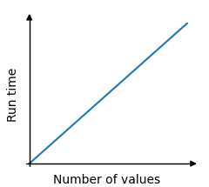

Stacks with Python

A stack is a linear data structure that follows the Last-In-First-Out (LIFO) principle.

Think of it like a stack of pancakes - you can only add or remove pancakes from the top.

Stacks
A stack is a data structure that can hold many elements, and the last element added is the first one to be removed.

Like a pile of pancakes, the pancakes are both added and removed from the top. So when removing a pancake, it will always be the last pancake you added. This way of organizing elements is called LIFO: Last In First Out.

Basic operations we can do on a stack are:

- Push: Adds a new element on the stack.
- Pop: Removes and returns the top element from the stack.
- Peek: Returns the top (last) element on the stack.
- isEmpty: Checks if the stack is empty.
- Size: Finds the number of elements in the stack.

Stacks can be implemented by using arrays or linked lists.

Stacks can be used to implement undo mechanisms, to revert to previous states, to create algorithms for depth-first search in graphs, or for backtracking.

Stacks are often mentioned together with Queues, which is a similar data structure described on the next page.

Stack Implementation using Python Lists

Since Python lists has good support for functionality needed to implement stacks, we start with creating a stack and do stack operations with just a few lines like this:

stack = []
# Push
stack.append('A')
stack.append('B')
stack.append('C')
print("Stack: ", stack)
# Peek
topElement = stack[-1]
print("Peek: ", topElement)
# Pop
poppedElement = stack.pop()
print("Pop: ", poppedElement)
# Stack after Pop
print("Stack after Pop: ", stack)
# isEmpty
isEmpty = not bool(stack)
print("isEmpty: ", isEmpty)
# Size
print("Size: ",len(stack))
While Python lists can be used as stacks, creating a dedicated Stack class provides better encapsulation and additional functionality:
class Stack:
def __init__(self):
self.stack = []
def push(self, element):
self.stack.append(element)
def pop(self):
if self.isEmpty():
return "Stack is empty"
return self.stack.pop()
def peek(self):
if self.isEmpty():
return "Stack is empty"
return self.stack[-1]
def isEmpty(self):
return len(self.stack) == 0
def size(self):
return len(self.stack)
# Create a stack
myStack = Stack()
myStack.push('A')
myStack.push('B')
myStack.push('C')
print("Stack: ", myStack.stack)
print("Pop: ", myStack.pop())
print("Stack after Pop: ", myStack.stack)
print("Peek: ", myStack.peek())
print("isEmpty: ", myStack.isEmpty())
print("Size: ", myStack.size())

More Basic Stack program:

stack = [] # Step 1: Create an empty stack (list)

# Step 2: Push (add) elements to the stack
stack.append(10)
stack.append(20)
stack.append(30)

print("Stack after pushing:", stack)

# Step 3: Pop (remove) the top element
top = stack.pop()
print("Popped element:", top)

# Step 4: Show final stack
print("Stack after popping:", stack)

Create a Stack using a class

class Stack:
def __init__(self):
self.items = [] # Create an empty list to store stack items

def push(self, item):
self.items.append(item) # Add item to the top

def pop(self):
return self.items.pop() # Remove and return the top item

def show(self):
print("Current Stack:", self.items) # Print current stack

# Using the Stack class
stack = Stack() # Create a new stack
stack.push(10) # Push 10
stack.push(20) # Push 20
stack.push(30) # Push 30

stack.show() # Show stack: [10, 20, 30]

print("Popped:", stack.pop()) # Pop the top (30)

stack.show() # Show stack: [10, 20]

Reasons to implement stacks using lists/arrays:

Memory Efficient: Array elements do not hold the next elements address like linked list nodes do.
Easier to implement and understand: Using arrays to implement stacks require less code than using linked lists, and for this reason it is typically easier to understand as well.

A reason for not using arrays to implement stacks:

Fixed size: An array occupies a fixed part of the memory. This means that it could take up more memory than needed, or if the array fills up, it cannot hold more elements.

Stack Implementation using Linked Lists

A linked list consists of nodes with some sort of data, and a pointer to the next node.

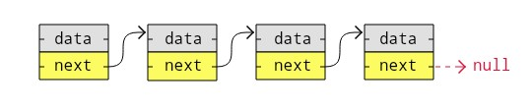

A big benefit with using linked lists is that nodes are stored wherever there is free space in memory, the nodes do not have to be stored contiguously right after each other like elements are stored in arrays. Another nice thing with linked lists is that when adding or removing nodes, the rest of the nodes in the list do not have to be shifted.

To better understand the benefits with using arrays or linked lists to implement stacks, you should check out this page that explains how arrays and linked lists are stored in memory.

Creating a Stack using a Linked List:

class Node:
def __init__(self, value):
self.value = value
self.next = None
class Stack:
def __init__(self):
self.head = None
self.size = 0
def push(self, value):
new_node = Node(value)
if self.head:
new_node.next = self.head
self.head = new_node
self.size += 1
def pop(self):
if self.isEmpty():
return "Stack is empty"
popped_node = self.head
self.head = self.head.next
self.size -= 1
return popped_node.value
def peek(self):
if self.isEmpty():
return "Stack is empty"
return self.head.value
def isEmpty(self):
return self.size == 0
def stackSize(self):
return self.size
def traverseAndPrint(self):
currentNode = self.head
while currentNode:
print(currentNode.value, end=" -> ")
currentNode = currentNode.next
print()
myStack = Stack()
myStack.push('A')
myStack.push('B')
myStack.push('C')
print("LinkedList: ", end="")
myStack.traverseAndPrint()
print("Peek: ", myStack.peek())
print("Pop: ", myStack.pop())
print("LinkedList after Pop: ", end="")
myStack.traverseAndPrint()
print("isEmpty: ", myStack.isEmpty())
print("Size: ", myStack.stackSize())

Simple Stack with Linked List

# Node class for each item in the stack
class Node:
def __init__(self, data):
self.data = data # Value stored in the node
self.next = None # Pointer to the next node
# Stack class using linked list
class Stack:
def __init__(self):
self.top = None # Top of the stack is initially empty
def push(self, item):
new_node = Node(item) # Create a new node
new_node.next = self.top # Point it to the current top
self.top = new_node # Update the top to the new node
def pop(self):
if self.top is None:
return "Stack is empty!" # Underflow condition
popped = self.top.data
self.top = self.top.next # Move top to the next node
return popped
def show(self):
current = self.top
print("Current Stack: ", end="")
while current:
print(current.data, end=" -> ")
current = current.next
print("None") # End of stack
# Using the Stack class
stack = Stack() # Create a new stack
stack.push(10) # Push 10
stack.push(20) # Push 20
stack.push(30) # Push 30
stack.show() # Show stack: 30 -> 20 -> 10 -> None
print("Popped:", stack.pop()) # Pop the top (30)
stack.show() # Show stack: 20 -> 10 -> None

A reason for using linked lists to implement stacks:

Dynamic size: The stack can grow and shrink dynamically, unlike with arrays.

Reasons for not using linked lists to implement stacks:

Extra memory: Each stack element must contain the address to the next element (the next linked list node).
Readability: The code might be harder to read and write for some because it is longer and more complex.
Common Stack Applications
Stacks are used in many real-world scenarios:

Undo/Redo operations in text editors
Browser history (back/forward)
Function call stack in programming
Expression evaluation

Queues with Python

A queue is a linear data structure that follows the First-In-First-Out (FIFO) principle.

Queues
Think of a queue as people standing in line in a supermarket.

The first person to stand in line is also the first who can pay and leave the supermarket.

Basic operations we can do on a queue are:

- Enqueue: Adds a new element to the queue.
- Dequeue: Removes and returns the first (front) element from the queue.
- Peek: Returns the first element in the queue.
- isEmpty: Checks if the queue is empty.
- Size: Finds the number of elements in the queue.

Queues can be implemented by using arrays or linked lists.

Queues can be used to implement job scheduling for an office printer, order processing for e-tickets, or to create algorithms for breadth-first search in graphs.

Using a Python list as a queue:

queue = []
# Enqueue
queue.append('A')
queue.append('B')
queue.append('C')
print("Queue: ", queue)
# Peek
frontElement = queue[0]
print("Peek: ", frontElement)
# Dequeue
poppedElement = queue.pop(0)
print("Dequeue: ", poppedElement)
print("Queue after Dequeue: ", queue)
# isEmpty
isEmpty = not bool(queue)
print("isEmpty: ", isEmpty)
# Size
print("Size: ", len(queue))
class Queue:
def __init__(self):
self.queue = []
def enqueue(self, element):
self.queue.append(element)
def dequeue(self):
if self.isEmpty():
return "Queue is empty"
return self.queue.pop(0)
def peek(self):
if self.isEmpty():
return "Queue is empty"
return self.queue[0]
def isEmpty(self):
return len(self.queue) == 0
def size(self):
return len(self.queue)
# Create a queue
myQueue = Queue()
myQueue.enqueue('A')
myQueue.enqueue('B')
myQueue.enqueue('C')
print("Queue: ", myQueue.queue)
print("Peek: ", myQueue.peek())
print("Dequeue: ", myQueue.dequeue())
print("Queue after Dequeue: ", myQueue.queue)
print("isEmpty: ", myQueue.isEmpty())
print("Size: ", myQueue.size())

Simple Python Queue

# Simple Queue implementation using list
queue = []
# Enqueue elements (add to the end)
queue.append("A")
queue.append("B")
queue.append("C")
print("Initial Queue:", queue)
# Dequeue elements (remove from the front)
print("Dequeued:", queue.pop(0))
print("Queue after dequeue:", queue)
# Add another element
queue.append("D")
print("Queue after enqueue D:", queue)
# Dequeue again
print("Dequeued:", queue.pop(0))
print("Final Queue:", queue)

Queue with a Class

class Queue:
def __init__(self):
self.items = []
def enqueue(self, item):
self.items.append(item) # Add to the end
def dequeue(self):
if not self.is_empty():
return self.items.pop(0) # Remove from the front
return None
def is_empty(self):
return len(self.items) == 0
def display(self):
print("Queue:", self.items)
# Example usage
q = Queue()
q.enqueue("A")
q.enqueue("B")
q.enqueue("C")
q.display()
print("Dequeued:", q.dequeue())
q.display()
q.enqueue("D")
q.display()
print("Dequeued:", q.dequeue())
q.display()

Queue Implementation using Linked Lists

A linked list consists of nodes with some sort of data, and a pointer to the next node.



A big benefit with using linked lists is that nodes are stored wherever there is free space in memory, the nodes do not have to be stored contiguously right after each other like elements are stored in arrays. Another nice thing with linked lists is that when adding or removing nodes, the rest of the nodes in the list do not have to be shifted.

Creating a Queue using a Linked List:

Creating a Queue using a Linked List:

class Node:
def __init__(self, data):
self.data = data
self.next = None
class Queue:
def __init__(self):
self.front = None
self.rear = None
self.length = 0
def enqueue(self, element):
new_node = Node(element)
if self.rear is None:
self.front = self.rear = new_node
self.length += 1
return
self.rear.next = new_node
self.rear = new_node
self.length += 1
def dequeue(self):
if self.isEmpty():
return "Queue is empty"
def isEmpty(self):
return self.length == 0
def size(self):
return self.length
def printQueue(self):
temp = self.front
while temp:
print(temp.data, end=" ")
temp = temp.next
print()
def dequeue(self):
if self.isEmpty():
return "Queue is empty"
temp = self.front
self.front = temp.next
self.length -= 1
if self.front is None:
self.rear = None
return temp.data
def peek(self):
if self.isEmpty():
return "Queue is empty"
return self.front.data
def isEmpty(self):
return self.length == 0
def size(self):
return self.length
def printQueue(self):
temp = self.front
while temp:
print(temp.data, end=" -> ")
temp = temp.next
print()
# Create a queue
myQueue = Queue()
myQueue.enqueue('A')
myQueue.enqueue('B')
myQueue.enqueue('C')
print("Queue: ", end="")
myQueue.printQueue()
print("Peek: ", myQueue.peek())
print("Dequeue: ", myQueue.dequeue())
print("Queue after Dequeue: ", end="")
myQueue.printQueue()
print("isEmpty: ", myQueue.isEmpty())
print("Size: ", myQueue.size())

Simple Queue in Linked List

class Node:
def __init__(self, data):
self.data = data
self.next = None
class Queue:
def __init__(self):
self.front = None
self.rear = None
def enqueue(self, item):
new_node = Node(item)
if self.rear is None: # Empty queue
self.front = self.rear = new_node
else:
self.rear.next = new_node
self.rear = new_node
def dequeue(self):
if self.front is None: # Empty queue
return None
data = self.front.data
self.front = self.front.next
if self.front is None: # Queue became empty
self.rear = None
return data
def is_empty(self):
return self.front is None
def display(self):
current = self.front
print("Queue:", end=" ")
while current:
print(current.data, end=" ")
current = current.next
print()
# Example usage
q = Queue()
q.enqueue("A")
q.enqueue("B")
q.enqueue("C")
q.display()
print("Dequeued:", q.dequeue())
q.display()
q.enqueue("D")
q.display()
print("Dequeued:", q.dequeue())
q.display()

Reasons for using linked lists to implement queues:
- Dynamic size: The queue can grow and shrink dynamically, unlike with arrays.
- No shifting: The front element of the queue can be removed (enqueue) without having to shift other elements in the memory.
Reasons for not using linked lists to implement queues:
- Extra memory: Each queue element must contain the address to the next element (the next linked list node).
- Readability: The code might be harder to read and write for some because it is longer and more complex.

Queues are used in many real-world scenarios:
- Task scheduling in operating systems
- Breadth-first search in graphs
- Message queues in distributed systems

Linked Lists with Python
A Linked List is, as the word implies, a list where the nodes are linked together. Each node contains data and a pointer. The way they are linked together is that each node points to where in the memory the next node is placed.

Linked Lists vs Arrays
The easiest way to understand linked lists is perhaps by comparing linked lists with arrays.
Linked lists consist of nodes, and is a linear data structure we make ourselves, unlike arrays which is an existing data structure in the programming language that we can use.
Nodes in a linked list store links to other nodes, but array elements do not need to store links to other elements.

The table below compares linked lists with arrays to give a better understanding of what linked lists are.
 | Arrays | Linked Lists
An existing data structure in the programming language | Yes | No
Fixed size in memory | Yes | No
Elements, or nodes, are stored right after each other in memory (contiguously) | Yes | No
Memory usage is low  (each node only contains data, no links to other nodes) | Yes | No
Elements, or nodes, can be accessed directly (random access) | Yes | No
Elements, or nodes, can be inserted or deleted in constant time, no shifting operations in memory needed  . | No | Yes
These are some key linked list properties, compared to arrays:
- Linked lists are not allocated to a fixed size in memory like arrays are, so linked lists do not require to move the whole list into a larger memory space when the fixed memory space fills up, like arrays must.
- Linked list nodes are not laid out one right after the other in memory (contiguously), so linked list nodes do not have to be shifted up or down in memory when nodes are inserted or deleted.
- Linked list nodes require more memory to store one or more links to other nodes. Array elements do not require that much memory, because array elements do not contain links to other elements.
- Linked list operations are usually harder to program and require more lines than similar array operations, because programming languages have better built in support for arrays.
- We must traverse a linked list to find a node at a specific position, but with arrays we can access an element directly by writing myArray[5].

Types of Linked Lists
There are three basic forms of linked lists:
- Singly linked lists
- Doubly linked lists
- Circular linked lists

A singly linked list is the simplest kind of linked lists. It takes up less space in memory because each node has only one address to the next node, like in the image below.

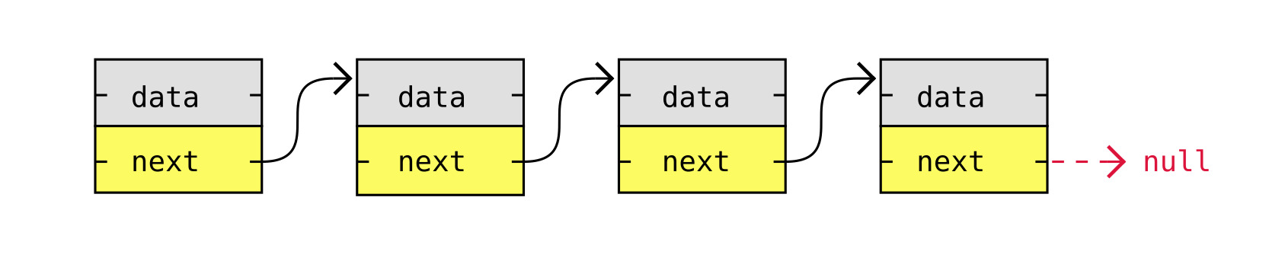

A doubly linked list has nodes with addresses to both the previous and the next node, like in the image below, and therefore takes up more memory. But doubly linked lists are good if you want to be able to move both up and down in the list.
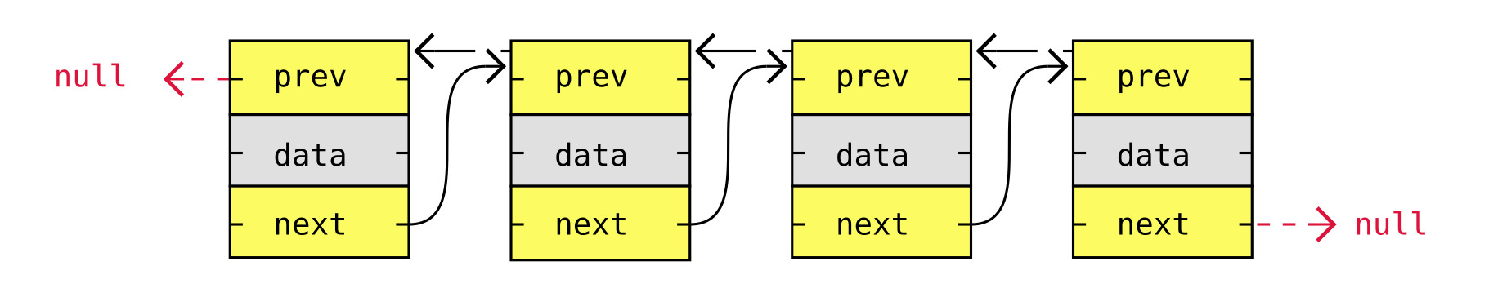

A circular linked list is like a singly or doubly linked list with the first node, the "head", and the last node, the "tail", connected.
In singly or doubly linked lists, we can find the start and end of a list by just checking if the links are null. But for circular linked lists, more complex code is needed to explicitly check for start and end nodes in certain applications.
Circular linked lists are good for lists you need to cycle through continuously.
The image below is an example of a singly circular linked list:
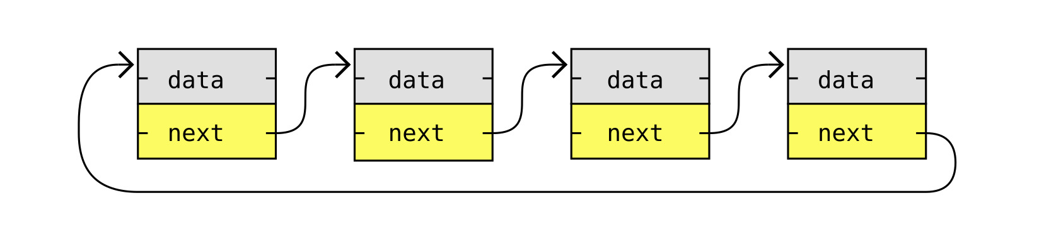
The image below is an example of a doubly circular linked list:

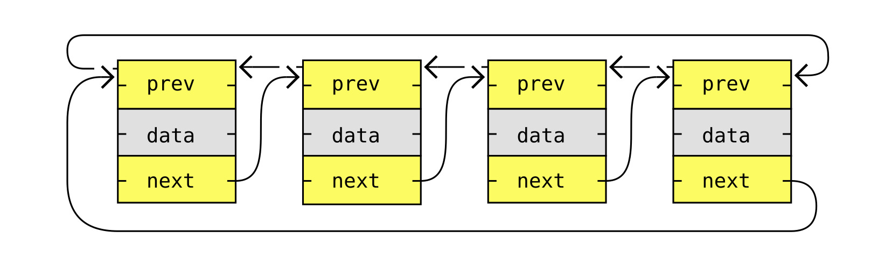

Linked List Operations
Basic things we can do with linked lists are:
- Traversal
- Remove a node
- Insert a node
- Sort
For simplicity, singly linked lists will be used to explain these operations below.

Traversal of a Linked List
Traversing a linked list means to go through the linked list by following the links from one node to the next.
Traversal of linked lists is typically done to search for a specific node, and read or modify the node's content, remove the node, or insert a node right before or after that node.
To traverse a singly linked list, we start with the first node in the list, the head node, and follow that node's next link, and the next node's next link and so on, until the next address is null.

Traversal of a singly linked list in Python:
class Node:
def __init__(self, data):
self.data = data
self.next = None
def traverseAndPrint(head):
currentNode = head
while currentNode:
print(currentNode.data, end=" -> ")
currentNode = currentNode.next
print("null")
node1 = Node(7)
node2 = Node(11)
node3 = Node(3)
node4 = Node(2)
node5 = Node(9)
node1.next = node2
node2.next = node3
node3.next = node4
node4.next = node5
traverseAndPrint(node1)

Find The Lowest Value in a Linked List
Let's find the lowest value in a singly linked list by traversing it and checking each value.
Finding the lowest value in a linked list is very similar to how we found the lowest value in an array, except that we need to follow the next link to get to the next node.
To find the lowest value we need to traverse the list like in the previous code. But in addition to traversing the list, we must also update the current lowest value when we find a node with a lower value.
In the code below, the algorithm to find the lowest value is moved into a function called findLowestValue.

Finding the lowest value in a singly linked list in Python:

class Node:
def __init__(self, data):
self.data = data
self.next = None
def findLowestValue(head):
minValue = head.data
currentNode = head.next
while currentNode:
if currentNode.data < minValue:
minValue = currentNode.data
currentNode = currentNode.next
return minValue
node1 = Node(7)
node2 = Node(11)
node3 = Node(3)
node4 = Node(2)
node5 = Node(9)
node1.next = node2
node2.next = node3
node3.next = node4
node4.next = node5
print("The lowest value in the linked list is:", findLowestValue(node1))

Delete a Node in a Linked List
If you want to delete a node in a linked list, it is important to connect the nodes on each side of the node before deleting it, so that the linked list is not broken.
So before deleting the node, we need to get the next pointer from the previous node, and connect the previous node to the new next node before deleting the node in between.
Also, it is a good idea to first connect next pointer to the node after the node we want to delete, before we delete it. This is to avoid a 'dangling' pointer, a pointer that points to nothing, even if it is just for a brief moment.

Deleting a specific node in a singly linked list in Python:
class Node:
def __init__(self, data):
self.data = data
self.next = None
def traverseAndPrint(head):
currentNode = head
while currentNode:
print(currentNode.data, end=" -> ")
currentNode = currentNode.next
print("null")
def deleteSpecificNode(head, nodeToDelete):
if head == nodeToDelete:
return head.next
currentNode = head
while currentNode.next and currentNode.next != nodeToDelete:
currentNode = currentNode.next
if currentNode.next is None:
return head
currentNode.next = currentNode.next.next
return head
node1 = Node(7)
node2 = Node(11)
node3 = Node(3)
node4 = Node(2)
node5 = Node(9)
node1.next = node2
node2.next = node3
node3.next = node4
node4.next = node5
print("Before deletion:")
traverseAndPrint(node1)
# Delete node4
node1 = deleteSpecificNode(node1, node4)
print("\nAfter deletion:")
traverseAndPrint(node1)

In the deleteSpecificNode function above, the return value is the new head of the linked list. So for example, if the node to be deleted is the first node, the new head returned will be the next node.

Insert a Node in a Linked List
Inserting a node into a linked list is very similar to deleting a node, because in both cases we need to take care of the next pointers to make sure we do not break the linked list.
To insert a node in a linked list we first need to create the node, and then at the position where we insert it, we need to adjust the pointers so that the previous node points to the new node, and the new node points to the correct next node.
- New node is created
- Node 1 is linked to new node
- New node is linked to next node

Inserting a node in a singly linked list in Python:
class Node:
def __init__(self, data):
self.data = data
self.next = None
def traverseAndPrint(head):
currentNode = head
while currentNode:
print(currentNode.data, end=" -> ")
currentNode = currentNode.next
print("null")
def insertNodeAtPosition(head, newNode, position):
if position == 1:
newNode.next = head
return newNode
currentNode = head
for _ in range(position - 2):
if currentNode is None:
break
currentNode = currentNode.next
newNode.next = currentNode.next
currentNode.next = newNode
return head
node1 = Node(7)
node2 = Node(3)
node3 = Node(2)
node4 = Node(9)
node1.next = node2
node2.next = node3
node3.next = node4
print("Original list:")
traverseAndPrint(node1)
# Insert a new node with value 97 at position 2
newNode = Node(97)
node1 = insertNodeAtPosition(node1, newNode, 2)
print("\nAfter insertion:")
traverseAndPrint(node1)

In the insertNodeAtPosition function above, the return value is the new head of the linked list. So for example, if the node is inserted at the start of the linked list, the new head returned will be the new node.

Time Complexity of Linked Lists Operations

Time complexity describes the approximate number of steps or operations an algorithm needs in relation to the size of its input (n), rather than the exact time it will take to run on a computer. This explains why two algorithms with the same time complexity, like linear search for arrays and linked lists (both are O(n)), can still have different actual runtimes. The real time depends on factors like the programming language, hardware, and how operations differ between arrays and linked lists
Linear search works similarly for arrays and linked lists: you check each value in order until you find the one you need, which gives a time complexity of O(n). However, binary search isn't practical for linked lists since it relies on quickly jumping to any element in the list, which isn't possible in linked structures.
Triply Linked list example

class Node:
def __init__(self, data):
self.data = data
self.next = None # points to the next node (below in stack)
self.prev = None # points to the previous node (above in stack)
self.random = None # special pointer (used to point to middle node)
class Stack:
def __init__(self):
self.top = None
self.size = 0
def push(self, data):
new_node = Node(data)
new_node.next = self.top
if self.top:
self.top.prev = new_node
self.top = new_node
self.size += 1
def pop(self):
if not self.top:
return None
data = self.top.data
self.top = self.top.next
if self.top:
self.top.prev = None
self.size -= 1
return data
def insert_middle(self, data):
if self.size < 2:
print("Not enough elements to insert in the middle.")
return
mid_index = self.size // 2
current = self.top
for _ in range(mid_index - 1):
current = current.next
# Insert new node after 'current'
new_node = Node(data)
new_node.next = current.next
new_node.prev = current
if current.next:
current.next.prev = new_node
current.next = new_node
# Set the random pointer of top to this new middle node
self.top.random = new_node
self.size += 1
def show(self):
print("Stack top ->", end=" ")
curr = self.top
while curr:
print(f"[{curr.data}]", end=" ")
curr = curr.next
print()
def show_random_from_top(self):
if self.top and self.top.random:
print("Top's random points to:", self.top.random.data)
else:
print("Top's random is None")
# ✅ Example usage
if __name__ == "__main__":
s = Stack()
s.push("A")
s.push("B")
s.push("C")
s.push("D")
s.push("E")
print("Before inserting in middle:")
s.show()
s.insert_middle("X")
print("\nAfter inserting 'X' in middle:")
s.show()
s.show_random_from_top()

